WOMEN ONSIDE LIMITED
ACN 637 323 105
2026 Annual General Meeting — Director Election
Candidate Information Pack
The following candidates have been nominated for election to the Board of Women Onside Limited at the 2026 Annual General Meeting, to be held on Monday, 21 September 2026 at 7.00pm AEST, online via Microsoft Teams. Members are invited to review each candidate's background and experience below ahead of casting their vote.

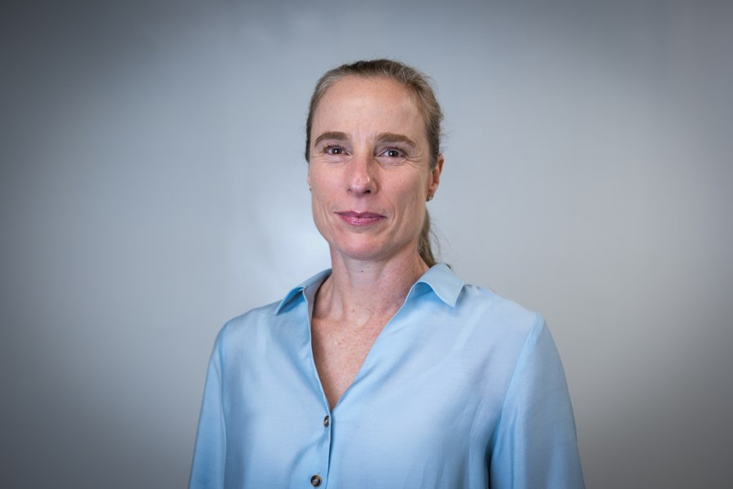 | Sarah Druce  Sarah is a legal and governance advisor with over two decades of experience within the corporate, technology, and human rights sectors. She has advised national and international organisations, not-for-profits, and emerging tech ventures.  Most recently, Sarah served as Senior Legal Counsel at UNICEF Australia, providing legal and governance guidance in support of the organisation's human rights mandate. Prior to this, she was Head of Legal at Car Next Door and later Uber Carshare, overseeing legal strategy for the major acquisition and rebrand. As a board member and company secretary, she guided mobility and financial services sector organisations, focusing on proactively managing risk and ensuring compliance within an evolving regulatory landscape.  In the past, Sarah has contributed to litigation for First Nations youth in detention and led strategic medico-legal claims for detainees in offshore processing centres. She has worked internationally with Aidha and UN Women on advancing financial literacy and gender equality initiatives within South-East Asia.  Sarah is passionate about ethical governance and the sustainable growth of human rights organisations.

 | Peter Filopoulos  Peter is a CEO, C-suite executive and board director with more than two decades of leadership across professional sport, major events, commercial enterprises and international sporting organisations in Australia and abroad. His career spans strategy, commercial and revenue growth, brand, customer, communications, corporate affairs, government relations and infrastructure delivery, with a consistent focus on building organisations, brands and partnerships that create lasting value.  Peter has twice been appointed Chief Executive Officer, leading Perth Glory Football Club and Football Victoria, and has held further C-suite and Executive Leadership Team roles including Chief Customer, Brand, Marketing and Communications Officer at Football Australia and Chief Commercial Officer at Swimming Australia. He currently serves as Managing Director - Experience at Bastion, advising boards, CEOs and rights holders across sport, entertainment and major events, and recently held the role of Chief Strategy and Marketing Officer at Canadian Soccer Media & Entertainment.  Over his career Peter has secured more than $900 million in government and infrastructure investment, including conceiving and securing funding for the $116 million Home of the Matildas, and delivered more than $80 million in annual commercial growth through partnerships with organisations including Commonwealth Bank, Nike and Optus. He helped transform the CommBank Matildas into one of Australia's most valuable and culturally significant sporting brands, and has held executive leadership roles across the FIFA Women's World Cup 2023 and the Sydney 2000 Olympic Football Tournament.  Peter holds a Bachelor of Business (Accounting major) from Deakin University and currently serves on the Board of Football Victoria. He is particularly motivated by governance, organisational transformation and the opportunities that sit at the intersection of sport, business and society, and believes great organisations are built on purpose, people and performance.

 | Brooke Reid  Brooke Reid is a senior sport and major event executive with more than 20 years' experience across football, elite sport and international tournament delivery, most recently serving as General Manager, Services for the AFC Women's Asian Cup 2026.  As Senior Partnerships Manager at Football Australia, she led commercial partnerships for the CommBank Matildas, including Commonwealth Bank, Cadbury and LEGO, using sponsorship platforms to directly grow the visibility and commercial value of women's football. Her event operations leadership with Qatar Foundation at the FIFA Men's World Cup saw her design accessibility-driven fan experiences for 500,000+ spectators and deliver the Future Leaders in Football workshop, empowering women across Qatar and the region.  She brings this same commitment to inclusion and opportunity to her current board roles with Women Onside and Manly Marlins Rugby Football Club, where she applies her sponsorship, governance and stakeholder management expertise to support the growth of women in sport. Brooke offers a rare combination of commercial acumen, large-scale event operations experience and a proven track record of expanding opportunities for women in football.

